**120 Square Meters of Bundled Sensor Expertise from Bavaria  
Focus on Chip Design, IIoT, and Environmental Technologies**

**Joint Exhibit of the Sensor Technology Cluster at SENSOR+TEST  
(May 6th to 8th, 2025, Nuremberg)**

**BAVARIA. Intelligent sensor networks, chip design "made in Bavaria", solutions for the Industrial Internet of Things (IIoT), precise measurement systems, ultrasonic and nanosensors, as well as sustainable technologies for the environment and energy – the joint exhibit of the Sensor Technology Cluster at SENSOR+TEST 2025 offers a comprehensive overview of Bavarian sensor industry’s innovation power. This year, 13 exhibitors will present their solutions at the 120 m² joint booth in Hall 1. The Sensor Technology Cluster itself will also showcase current projects in the fields of inline measurement technology, digital solutions for civil protection and water management. State Secretary Tobias Gotthardt will also take the opportunity to gain an on-site impression of the sensor expertise during a tour.**

**From May 6th to 8th, 2025, SENSOR+TEST will open its doors in Nuremberg.** As the leading trade fair for sensor technology, measurement, and testing, it provides a comprehensive overview of current developments and applications. The Sensor Technology Cluster, the voice of the Bavarian sensor industry, leverages this platform to highlight the innovation capabilities of Bavarian companies. As a central interface between business and science, the Cluster supports the industry comprehensively and fosters exchange within national and international networks.

The Strategic Partnership for Sensor Technologies, the umbrella organization of the Cluster, has been consolidating the expertise of Bavarian companies, universities, and research institutions for over 15 years. Through cross-industry collaborations, it advances technological solutions and promotes international technology transfer as well as the competitiveness of its members.

**Exhibitors at the Joint Booth of the Sensor Technology Cluster**

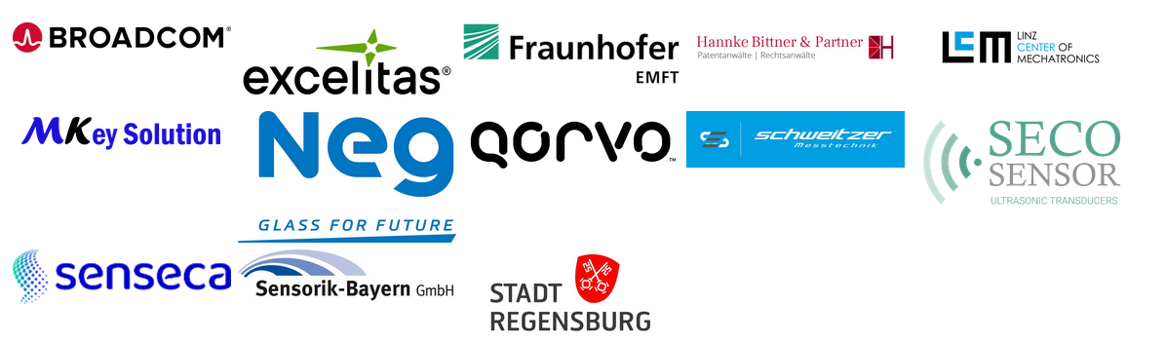

In 2025, Broadcom Inc., Excelitas Technologies Corp., Fraunhofer EMFT, Hannke Bittner & Partner, Linz Center of Mechatronics (LCM), MKey Solution, Nippon Electric Glass (NEG), Qorvo, Schweitzer Messtechnik, SECO Sensor and Senseca will provide insight into their portfolios. The range of topics covers semiconductor solutions and chip technology, industrial communication technology, energy-efficient ultrasonic transducers, smart glass solutions and sensor components for automation and environmental technologies. The Bavarian sensor industry is also significantly involved in initiatives such as the Bavarian Chips Alliance and plays a key role in shaping international developments in the fields of microelectronics, IIoT and GreenTech.

Companies, research institutions and trade visitors will gain concrete insights into current solutions and opportunities for cooperation by visiting the joint booth. Upon request, a personalized tour can be arranged in advance by email to info@sensorik-bayern.de.

**Free tickets and information about the co-exhibitors can be found at  
[The Joint Booth of the Sensor Technology Network at SENSOR+TEST 2025](https://www.sensorik-bayern.de/sensor-test)**

**[Details on Other Activities within the Sensor Technology Cluster](http://www.sensorik-bayern.de/)**

**PRESS CONTACT:**

**Strategische Partnerschaft Sensorik e.V.**  
**Sensor Technology Cluster Management**

Management  
Stefanie Fuchs  
Franz-Mayer-Strasse 1  
93053 Regensburg  
Phone: +49 (0)941 63 09 16-13  
Email: s.fuchs1@sensorik-bayern.de  
Website: www.sensorik-bayern.de